MASTER PROGRAM

Quantitative Finance and Risk Management

**VARIANCE REDUCTION: ANTITHETIC VARIATES, CONTROL VARIATES AND IMPORTANCE SAMPLING TECHNIQUES**

*Author*:

SIBI Cheik Badr Ali

*Professor*:

Dr. Irina KORTCHEMSKI

1. **The variance reduction**

To simulate a sample, in mathematics, we can use the Monte Carlo methods to realize these simulations. Indeed, these simulations has an error variance and to reduce this error we use some techniques such as the variance reduction methods. This technique allows to produce an efficiency estimator by improving the efficiency of Monte Carlo method.

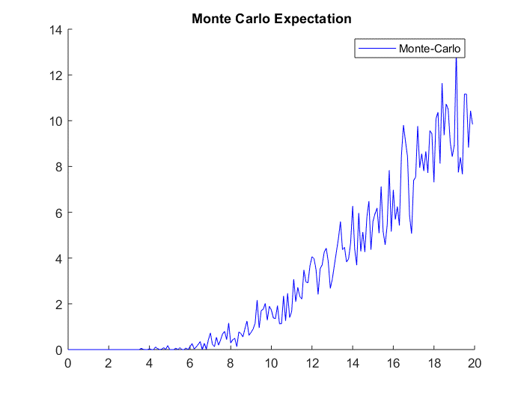

Figure 1- The propagation of the Monte-Carlo expectation not using the variance reduction method

As on the image above, we notice that the propagation of the Monte Carlo expectation is not smooth due to the variance value used. Which seems large. Although, the variance reduction methods improve the propagation of the Monte Carlo expectation by giving it back almost smooth.

Therefore, with the variance reduction methods, we create a new variable related to a given one whose the expectations have the same value. Then, the idea is to compute the variance of the new variable created such as it is less than the first one. Thus, to do that we have three methods, listed below.

* 1. **Antithetic Variates**

This method is based on the Brownian Motion symmetric property *Wt* and *-Wt*. From this property we assume two functions correlated such that their covariance must be negative. Then, we compute its variance, which one must be less than the initial variance.

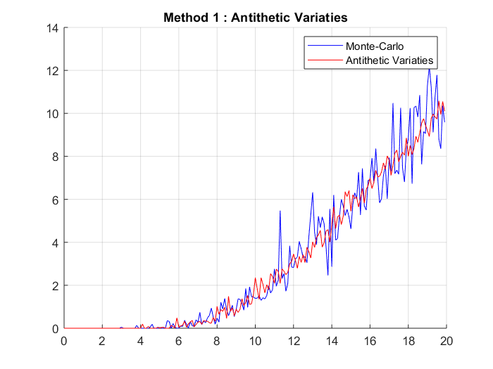

Figure 2- The graphs of the Monte-Carlo expectation versus Antithetic Variates a variance reduction method. We notice that the Antithetic Variates largely reduce the propagation compare to the initial Monte Carlo method.

* 1. **Control Variates**

This method uses two random variables with the same expectation value: the target random variable X and a new one Z = X – b (Y – E[Y]), b is a number, the covariance of X and Z is known and E[X] = E[Z]. Then, knowing their expectation value, we compute their variance value, except here, at the end we have that: Var[Z] < Var[X].

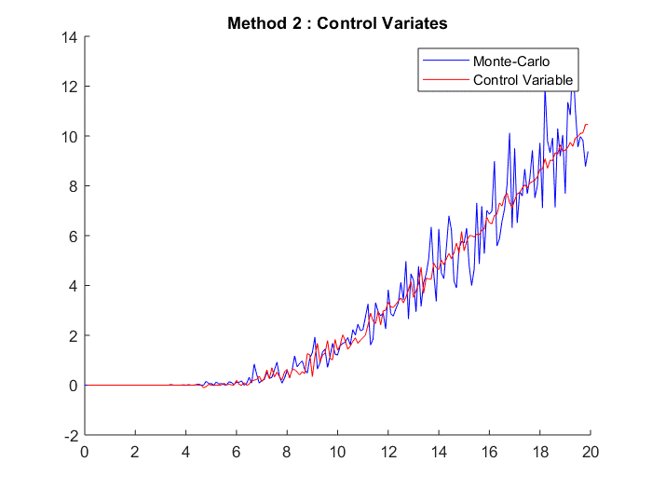

Figure 3- The graphs of the Monte-Carlo expectation versus Control Variates a variance reduction method. We notice that the Control Variates largely reduce the propagation compare to the initial Monte Carlo method.

* 1. **Importance Sampling Technique**

We assume a function *f* and we need to reduce its variance *Var[f]* by using the Importance Sampling Technique method. The idea is to replace in the simulation, the uniform density on *[a; b]* by a biased density, denoted *z*, which attempts to imitate the function *f*. Then, we replace the uniform draws, which are not good for any region, by the good ones. Thus, the sampling is done in according to the function *f*. Therefore, the variance is reduced. In other words, if a given error level is set, the preferential sampling theoretically reduces the number of simulations compared to a conventional Monte Carlo method.

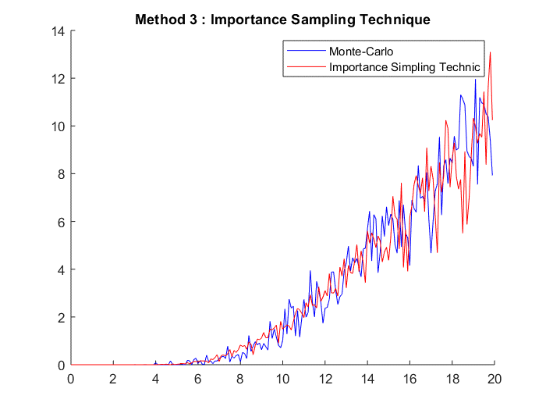

Figure 4- The graphs of the Monte-Carlo expectation versus Importance Sampling Technique a variance reduction method. We notice that the Importance Sampling Technique reduce the propagation compare to the initial Monte Carlo method.